REQUEST FOR PROPOSAL
GAPS_FY2024_C2_WAHS_CAB
E-rate Funding Year 2024

DEFINITION OF TERMS
28-DAY WAITING PERIOD: The minimum time period an applicant is required to wait after posting the FCC Form 470 before entering into any contract with a service provider.
APPLICANT: The entity applying for universal service support. In the Schools and Libraries Program the entity is a school, library, consortium, or other eligible entity that files program forms.
BILLED ENTITY NUMBER (BEN): A unique number assigned by USAC to each billed entity (school, library, or consortium) that pays for services.
BILLED ENTITY: The entity that receives the bill and pays for the supported service. A billed entity may be different from the physical location being supported.
CATEGORY TWO BUDGET: Starting with FY2015, applicants applying for category two services will be limited to a five year pre-discount budget for those services.
CATEGORY TWO SERVICES (Cat 2): Internal connections services needed to enable high-speed broadband connectivity and broadband internal connections components. Category two includes local area networks/ wireless local area networks (LAN/ WLAN), internal connections components, basic maintenance of internal connections components, and managed internal broadband services.
CHILDREN’S INTERNET PROTECTION ACT (CIPA): A law that mandates certain internet safety policy and filtering requirements for recipients of E-rate Program discounts for services other than telecommunications services.
DARK FIBER INCLUDING INDEFEASIBLE RIGHTS OF USE (IRU): The E-rate applicant leases capacity (i.e. a specific number of fiber strands) on a provider-owned and maintained fiber network. The applicant pays separately for modulating equipment to light the fiber in order to transmit data over that fiber. The maintenance and operations (M&O) charges related to leased dark fiber service can be the responsibility of the service provider or the applicant dependent on the terms of the contractual agreement.
DOCUMENT RETENTION: Applicants and service providers must retain documentation related to the application for, receipt, and delivery of discounted services for at least 10 years from the last date of service delivery.
FCC FORM 470: The description of services requested and certification form is an FCC form that schools and libraries complete to request services and establish eligibility.
FCC FORM 471 FILING WINDOW: The period generally between mid- January and mid-March (prior to the start of the funding year) when forms filed are treated as having been received on the same day and are considered for funding before any other forms filed after the window closes.
FCC FORM 471: The services ordered and certification form is an FCC form that schools and libraries use to report services ordered and discounts requested for those services.
FCC FORM 472 (BEAR): The billed entity applicant reimbursement form is an FCC form that schools and libraries submit to USAC after paying for services in full, to request reimbursement for the discount on those services.
FCC FORM 474 (SPI): The service provider invoice form is an FCC form that service providers submit to request reimbursement for discounted eligible services already provided to the schools or libraries on their customer bills.
FUNDING YEAR: The funding year is a time during which program support is being provided. The Funding Year begins July 1 and ends June 30 of the following calendar year.
INVOICE: A statement or document that (1) service providers submit to USAC after they have provided or completed service to the applicant or (2) applicants submit to USAC after they have paid for services in full. Invoices are submitted using FCC Form 474 (service providers) or FCC Form 472 (applicants).
LIT FIBER: A fiber-based broadband service where the service provider owns and manages the network, and the E-rate applicant pays a recurring fee to have data transported over the network.
LOCAL AREA NETWORK (LAN): A voice, data, and/or video network that provide connections generally within an eligible school or library to other locations within the school or library.
LOWEST CORRESPONDING PRICE (LCP): The lowest price that a service provider charges to non-residential customers who are similarly situated to a particular E-rate program applicant (school, library, or consortium) for similar services.
NON-INSTRUCTIONAL FACILITY (NIF): A school building without classrooms or a library building without public areas. Examples of school NIFs include administrative buildings, bus barns, and cafeteria facilities. Examples of library NIFs include administrative buildings, bookmobile garages, and interlibrary loan facilities.
POINT OF DEMARCATION (Demarc): A demarcation refers to the point where a service provider’s network ends and where an applicant’s local area network (LAN) begins.
PROPOSER: A service provider that provides a formal response to the request for proposal.
REQUEST FOR PROPOSAL (RFP): A form of solicitation for products or services that provides detailed information regarding those products or services and any additional details necessary for potential proposers to respond. Program applicants may issue RFPs in addition to filing the FCC Form 470.
SELF-PROVISIONED NETWORK (Applicant Owned Fiber): Complete applicant ownership of a high-speed broadband network. The applicant hires a service provider to construct the network or a portion of the network, and thereafter owns and maintains that network or portion, including all the fiber strands and conduit.
SERVICE PROVIDER: A company that participates in the Schools and Libraries Program and provides telecommunications or internet services, equipment, hardware, or software to applicants.
SERVICE PROVIDER IDENTIFICATION NUMBER (SPIN): A unique number that USAC assigns to each service provider once that service provider has submitted the FCC Form 498 to USAC.
WIDE AREA NETWORK (WAN): A voice, data, and/or video network that provides connections from within an eligible school or library to other locations beyond the school or library.

OBJECTIVE
Greater Albany Public School District, hereafter referred to as Applicant, is requesting proposals for Category Two Internal Connections service.

SCHEDULE
Issue Date: | 12/13/2023
Questions Due Before: | 1/05/2024
Responses Due: | 1/10/2025

DISTRICT INFORMATION
District Name: | Greater Albany Public School
BEN: | 144935
Cat 1 Discount Rate: | TBD currently 80%
Cat 2 Discount Rate: | TBD currently 80%
Address: | 718 7th Ave SW
 | Albany, OR 97321-2320
Telephone: | 541-967-4501

SINGLE POINT OF CONTACT
Contact Name: | Leah Guilford
Address: | 3610 Grand Prairie Rd SE
 | Albany, Or 97322
Telephone: | 541-917-3495
Email: | leah.guilford@albany.k12.or.us

E-RATE REQUIREMENTS
Work Contingent upon Funding
Work offered in this RFP may be contingent upon receiving a funding commitment from USAC for the specified services. If the funding request is denied, the project may canceled. Such cancellations shall not constitute any financial obligation on the part of the applicant.

E-rate Eligible Provider
The work awarded as a result of this RFP must qualify for E-rate funding. Bidding service providers must have a relationship in good standing with FCC/USAC/SLD and qualify as an E-rate eligible provider. Information about E-rate and eligibility is available at the Universal Service Administration Company (USAC) website: http://www.usac.org/sl.
Service Provider Identification Number
Bidding service provider must have valid Service Provider Identification Number (SPIN). Information about E-rate and eligibility is available at the Universal Service Administration Company (USAC) website: https://www.usac.org/sl/service-providers/step01/default.aspx

E-rate Contact
The service providers must provide an E-rate contact for the applicant who understands the E-rate process and can answer related questions at the time of bidding.
In the field provided, list the name, phone number and email address for the E-rate contact that will be assigned to the Applicant's account.
Public Information
The successful service provider may not require any language in the final agreement that restricts publication of pricing data. Information, other than trade secrets as defined in ORS 192.501(2), contained in a response to this RFP and resulting contract, is public record and subject to disclosure.
Signed Contract
The successful service provider must be willing to enter into the agreement before the end of the E-rate filing window for the indicated funding year to meet E-rate requirements.

Favorable Pricing
Pricing offered under this RFP must not be higher than the lowest price offered to nonresidential customers who are similarly situated, for similar E-rate program services.

Period of Contract
Contract period will correspond with the E-rate funding year. Category one recurring services will be contracted in increments of one year that start July 1 of each funding year through June 30 of the following year. Category two services will be from July 1 of the funding year through September 30 following the end of the funding year. Extensions to the contract will be allowed according to E-rate rules.

Contract Term Modification
The applicant will reserve the right to extend or abbreviate the contract period if such extension or abbreviation is necessary to make the contract term coincide with an E-rate funding year, there is a delay in a funding commitment from USAC, or an extended service end date for an E-rate funding year pursuant to a service delivery deadline extension, as those terms are defined by the Federal Communications Commission (FCC) and/or the Universal Service Administrative Company (USAC).

Category Two Budgets
If combined total for all products and services exceeds remainder of an entities category two budget, the applicant may choose to select to only purchase products and services offered up to the amount remaining in the category two budget. Information about E-rate category two budgets is available at the Universal Service Administration Company (USAC) website: https://www.usac.org/sl/applicants/step03/category-two-budget.aspx

Product Substitutions
No change in the products and/or services specified in this document will be allowed without prior written approval from the applicant and a USC service substitution approval with the exception of a global service substitution.

Free Service Advisory
Services offered must be in full compliance USAC’s free service advisory. No free services may be offered that would predicate an artificial discount and preclude the applicant from paying its proportionate non-discounted share of costs.

Service Delivery Dates
The E-rate funding year begins on July 1st and expires on June 30 of the following year, resulting in a period of 12 months. No products or services may be delivered earlier than the start of the funding year. Category two services may be purchased and installed as early as April 1st prior to the start of the funding year, although the equipment must not be operational until July 1st. Installation of category two services must be completed by September 30th following the conclusion of the funding year.

Refurbished Equipment
No refurbished equipment will be accepted.

Equivalent Products and Services
Whenever specifications of any products or services are indicated by a specific proprietary name, manufacturer name, or model name, such specifications shall be deemed to be used the purpose of facilitating a description of the products or services desired and any products or services of equal or greater equivalency will be considered.
E-rate Forms
The successful service provider must accept either Billed Entity Application Reimbursement (BEAR) FCC Form 472, or Service Provider Invoice (SPI) FCC Form 474, invoicing per E-rate rules. The invoicing method chosen will be at the discretion of the applicant.

SUBMISSION REQUIREMENTS

Submission Guidelines
Proposals shall be enclosed in a sealed envelope, or .zip file and delivered to the single point of contact though mail or email. All proposals need to be clearly identified as a proposal for this Request for Proposal (RFP). Email subject lines should reference the Form 470 number.

Single Proposal
This RFP is limited to one response per proposer. Applicant is not requesting alternate proposals, and will not evaluate more than one offer per proposer.

Late Submissions
Proposer is solely responsible for ensuring its proposal is received by the applicant in accordance with the RFP requirements before response due date. Applicant is not responsible for any delays in mail or by common carriers or by transmission errors or delays or mistaken delivery. Proposal submitted by any means not authorized may be rejected. Proposals received after response due date are considered LATE and will NOT be accepted for evaluation. Late proposals will be returned to the respective proposer or destroyed.

Modification or Withdrawal of Proposals
Any proposer who wishes to make modifications to a proposal already received by applicant shall submit its modification to the single point of contact and must denote the specific change(s) to the proposal submission. All proposal modifications must be completed prior to closing.
If a proposer wishes to withdraw a submitted proposal, it shall do so prior to closing. The proposer shall submit a written notice signed by an authorized representative of its intent to withdraw its proposal in accordance with OAR 125-247-0440.

Partial Bids
Partial bids will be accepted however, bids that meet the full requirements outlined in the “Line Items” portion of the RFP will be scored higher during the evaluation process. If only partial bids are received, applicant may choose not to award the contract, or award the contract to multiple service providers.

Product Eligibility
The proposer must include E-rate eligibility percentages for each product and/or service listed in the bid.

Proposal Rejection
Agency may reject a proposal for any of the following reasons:
Proposer fails to substantially comply with all prescribed RFP procedures and requirements, including but not limited to the requirement that proposer’s authorized representative sign the proposal.
Proposer makes any contact regarding this RFP with applicant staff other than the single point of contact or those the single point of contact authorizes, or inappropriate contact with the single point of contact.
Proposer attempts to inappropriately influence a member of the evaluation committee.
Proposal is conditioned on applicant’s acceptance of any other terms and conditions or rights to negotiate any alternative terms and conditions that are not reasonably related to those expressly authorized for negotiation in the RFP or addenda.
The proposal does not include the eligibility percentage of each product and/or service listed.
The district has a right to reject any and all quotes, or any or all items of any quote. The district also reserves the right to decrease the proposed quantity. In the event quantities are decreased, the amount deducted shall be based upon prices quoted.

Addenda to Solicitation
Addenda to proposal shall be posted in the same manner as the proposal. Service provider is responsible for monitoring proposal for addendum and adjusting proposals.

Confirm your understanding of the submission requirements.
Initial

SCORING CRITERIA
Cost of Eligible Services (40 points possible)
Provide itemized costs and eligibility percentages for the specified equipment or services, including all components necessary for the equipment or service to be fully functional. Any services, equipment, or components that are not eligible for E-rate funding must be specified in response.
Prior Positive Experience (20 points possible)
Vendors who have provided services to the applicant in the past can be awarded up to 20 points based on the quality of work performed, and the positive working relationships between the applicant and the service provider while that work was being performed.

Experience Providing Similar Services of a Similar Scope (20 points possible)
The successful Service Provider will need to demonstrate experience providing services of similar scope and complexity. Attach a discussion of your firm's experience with working with three (3) entities of similar scope and complexity. Please provide contact information for reference checks where applicable.
Equipment (20 points possible)
The equipment bid is equivalent to the items requested in the Form 470 and/or RFP, and will work seamlessly in the districts network environment, including with any online management tools utilized by the district.

  - Total Possible Score: 100

Confirm your understanding of the Scoring Criteria.
Initial

DISQUALIFICATION CRITERIA
Bids received that do not meet the requirements specified in this RFP will be disqualified and will not be evaluated.
Bids received that do not meet the requirements specified in the scoring criteria section of this RFP will be disqualified as we will be unable to perform a proper evaluation of incomplete responses.

Confirm your understanding of Disqualification Criteria.
Initial

AWARD PROCESS

Notice of Award
Applicant will notify all proposers in writing that applicant is awarding a contract to the selected proposer(s) subject to successful negotiation of any negotiable provisions. Applicant reserves the right to award multiple vendors at their own discretion.

Protests
Protests of bid specifications shall be presented to the single point of contact in writing within five calendar days prior to bid closing. Such protest shall include the reason(s) for protest and any proposed changes. If, in the opinion of applicant, a change is required for the request for proposal, an addendum will be issued.
Protests of award shall be presented to the single point of contact in writing within five calendar days after the notice of award, or in the event of meeting E-rate deadlines, five (5) calendar days before the end of the E-rate FCC Form 471 filing window. Such protest shall include the reason(s) for protest and any proposed changes. If, in the opinion of applicant, a change is required for the award, a new notice of award will be issued.

Confirm your understanding of Award Process.
Initial

CONTRACT REQUIREMENTS

Contract
The successful service provider, if one is selected, will be required to enter into a written agreement in a form approved by the applicant. The agreement shall include, but shall not be limited to, the following terms and conditions:

Incorporation of Bid Documents
All specifications, terms and conditions contained in the RFP shall be incorporated by reference and made a part of a contract awarded to the successful service provider.

Compliance with Laws
The contract is a public contract subject to all applicable requirements of state and federal law, including but not limited to the following:
- 279B.045 – Compliance with all tax laws.
- 279B.220 – Prompt payment; no liens
- 279B.230 -- Payment for medical care; workers’ compensation.
- 279B.235 -- Hours of labor; compliance with pay equity provisions; employee discussions of rate of pay or benefits.

Failure to Perform
If a contract is awarded to a service provider and that service provider fails to perform, the service provider shall be liable for all costs and damages incurred by applicant in procuring and obtaining any similar equipment, article, material or service from other providers, and the contract awarded to the successful service provider shall be in full force and effect to the extent not terminated. Applicant reserves the right to revoke and terminate a contract award upon the service provider’s failure to perform, which termination shall not affect any right, obligation or liability of the service provider that accrued before such termination. In addition to the rights set forth in this paragraph, applicant reserves all other rights and remedies at law and in equity.

Termination
If a contract is awarded and the service provider breaches a term or condition of the contract, applicant may terminate the contract after providing five (5) days’ written notice of termination to the service provider. In addition to the right to terminate under the contract, applicant reserves all its rights and remedies at law and in equity available due to the breach, including but not limited to the recovery from the service provider any damages, costs, expenses and attorney fees (including fees incurred on appeal) arising out or as a result of a breach.

If applicant breaches a term or condition of the contract, the service provider’s sole remedy shall be termination of the contract and receipt of payment by applicant for any equipment, article, material or service provided by the contractor up to and including the effective date of termination.

Confirm your understanding of these requirements.
Initial

Invoicing
The successful service provider shall itemize, price, and invoice separately any materials or services that are ineligible for E-rate funding. Service provider must include the following information on all invoices to the applicant for E-rate eligible equipment and/or services:
- Date of invoice
- Date(s) of service
- Funding Request Number (FRN)
- SPIN
- Service provider’s signature on invoice attesting to the accuracy and completeness of all charges
- Detailed description of services performed and materials supplied that matches Applicant’s contract specifications, Form 470 and Form 471 descriptions of same
- Clear, concise breakdown of amount(s) to be billed to USAC (discounted portion of eligible charges) and amount(s) to be billed to the applicant (non-discounted amount of eligible charges)
- Invoice on service provider’s letterhead or on a service provider-generated form
- Applicant’s billed entity number (BEN)
- Applicant’s Federal Communications Commission registration number
- Proper E-rate discount percentage as set forth by the applicable FRN and USAC Funding Commitment Decision Letter (FCDL)
The service provider must ensure that applicant-approved substitute services or products are prominently noted on invoices submitted to USAC and the applicant.
The successful service provider shall be solely responsible for timely filing invoices with USAC. Accordingly, service provider understands and agrees that applicant will NOT be liable to service provider and service provider shall have no recourse against the applicant for any discounted amount that service provider submits late to USAC for payment, if USAC refuses to pay the invoice due to late filing.
The successful service provider understands and agrees that applicant shall not be liable to service provider and service provider shall have no recourse against the applicant for any discounted amount that service provider submits to USAC for payment if service provider is at fault for USAC’s refusal to pay; if the applicant is at fault, the applicant shall not be liable to service provider and service provider shall have no recourse against the applicant for the amount at issue until both the applicant and the service provider have exhausted their administrative remedies of appeal to USAC and/or the FCC.
In the event of a delayed funding commitment the successful service provider shall invoice USAC for the discounted amount the applicant is owed retroactive to July 1st of the funding year or to whenever approved service to the applicant began, whichever date is later.
Products and services must be delivered before billing can commence. At no time may the service provider invoice before the state of the aforementioned funding year.
Documentation
Service provider shall provide to applicant all of the information and documentation that the service provider has, or that service provider can reasonably acquire, that the applicant may need to prepare its E-rate applications and/or to meet the documentation standards required to receive E-rate support. This includes identifying the eligibility percentage of each product and/or service.
Service provider shall maintain all bids, quotes, records, correspondence, receipts, vouchers, delivery information, timesheet, memoranda and other data relating to service provider’s services to the applicant. All such records shall be retained for a minimum of ten (10) years following completion of services and shall be subject to inspection and audit by the applicant. Service provider shall include all subcontractor agreements for services, provisions requiring subcontractors to maintain the same records and allowing the applicant the same right to inspect and audit those records.

Confirm your understanding of the E-rate requirements.
Initial

TECHNICAL ENVIRONMENT
Recipients of Service related to this RFP

# | Entity | Address | NIF
1 | West Albany High School | 2100 Elm St SW Albany, OR 97321

SCOPE OF WORK
Definition
West Albany High School Stadium is seeking 6 wireless access points, as well as cabling installation. The products and/or services and quantities are outlined in the Line Items portion of this RFP. The products and/or services being requested are as follows:​ Cabling – A total of six outdoor network drops. 5 network drops must have 2 network jacks and 1 network drop must have 4 network jacks, for a total of 14 network drops with CAT6A cabling. Cabling must be yellow. For the terminations in the IDF, Blue Leviton CAT 6A keystone Part# 6110G-RL6 or equivalent, for the existing Leviton patch panel. For the outside termination, recommend an outdoor-rated jack or something that has protection against the outdoor elements. Below is a picture of where the drops to Apps are located under the overhang at the stadium. The drops should be mounted at the location specified. A walkthrough is mandatory prior to bid. Please contact GAPS Technology at leah.guilford@albany.k12.or.us, to schedule a walkthrough.
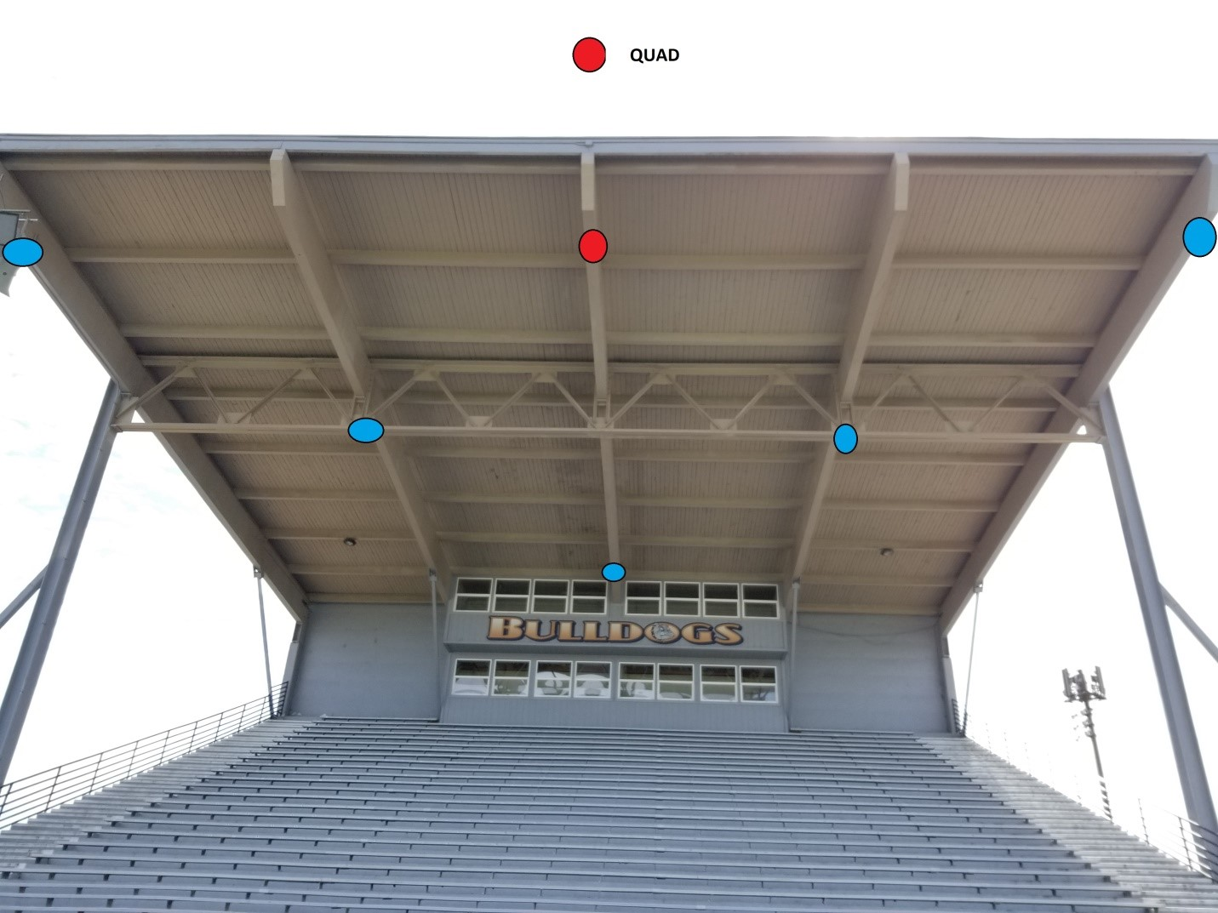
Cisco wireless access points, or their equivalent – All components, parts, power supplies, licenses and/or service agreements for equipment to be fully functional will need to be provided. Installation will be required for the Wireless Access Points.

☒ Installation/Configuration Needed

Line Items
# | Item | Make or Model, or equivalent | Quantity or Capacity
1 | Cisco 9124AXD | Cisco Directional Outdoor Wireless Access Point | 3
2 | Cisco 9124AXI | Cisco Omnidirectional Outdoor Wireless Access Point | 3
3 | Cisco EDU-DNA-E-5Y | Cisco Wireless DNA License | 6
4 | Cat 6a cable runs | Cabling | 14 runs (estimated 2,000 feet)
5 | Initial Installation, and configuration | Installation | 1

PROPOSER INFORMATION AND CERTIFICATION
Company Name:
SPIN:
Contact Name:
Address:
Telephone:
Fax:
Email:

By submitting a response, you certify that you are authorized to represent your company.

Signature: |  | Date:

